# Project

## Deciding on a venue for new hotel opening in New York and Canada.

Submitted by:

Sumit Rajput

Date 11/08/2020

# PROBLEM & BACKGROUND

* Toronto and New York are the famous places in the world. They are diverse in many ways. Both are multicultural as well as the financial hubs of their respective countries. We want to explore how much they are similar or dissimilar in aspects from a hotel business point of view regarding food, accommodation, beautiful places, and best place to open a hotel in both the places.
* Today Hotel business is one of the pillars of the economy and the people most often visits these countries who are rich in heritage and developed enough from a foreign prospective.therefor finding a venue for business is an important key point.
* Every city is unique in their own way and give something new. And now the information is so common regarding location of every place around the world on your fingertips which make it easier to explore.
* Therefore, Customer always eager to visit to different places on the basis of available information, and the comparison (the part of the information) between the two to find out the best place in Canada and new York to open a hotel and gain maximum profit with less investment

# DATA DESCRIPTION[¶](http://localhost:8891/notebooks/Desktop/CERTIFICATION/COURSERA/visualization/The%20Battle%20of%20Neighborhoods%20Week1.ipynb#DATA-DESCRIPTION)

* For this problem, we will get the services of Foursquare API to explore the data of two cities, in terms of their neighborhoods. The data also include the information about the places around each neighborhood like existing restaurants, hotels, coffee shops, parks, theaters, art galleries, museums and many more.
* We selected one Borough from each city to analyze their neighborhoods. Manhattan from New York and Downtown Toronto from Toronto.
* We will use machine learning technique, “Clustering” to segment the neighborhoods with similar objects on the basis of each neighborhood data. These objects will be given priority on the basis of foot traffic (activity) in their respective neighborhoods. This will help to locate the best areas and hubs, and then we can judge the similarity or dissimilarity between two cities on that basis.
* '<https://en.wikipedia.org/wiki/List_of_postal_codes_of_Canada:_M'> for canada neighbourhood
* geospatial-coordinates-toronto/Geospatial_Coordinates.csv" for latidtude and longitude.
* neighborhoods_NY.csv Analyze Borough and neighborhoods for Manhattan

Downtown_toronto data:

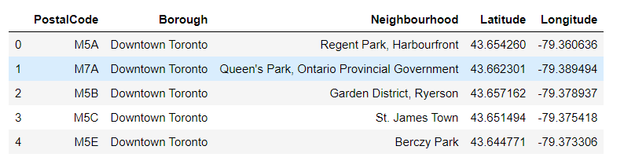

Manhattan_data:

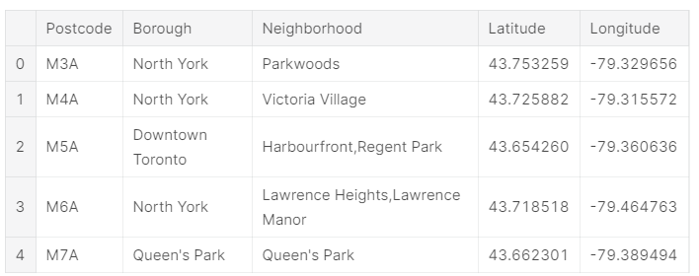

METHODOLOGY[**¶**](http://localhost:8891/notebooks/Desktop/CERTIFICATION/COURSERA/visualization/The%20Battle%20of%20Neighborhoods%20Week1.ipynb#METHODOLOGY)

* As we have selected two cities Borough to explore their neighborhoods. The data exploration, analysis and visualization for both boroughs are done in the same way but separately.

# EXPLORATION

* For Downtown Toronto case, we have extracted table of Toronto’s Borough from Wikipedia page. Then we arrange the data according to our requirements. In the arrangement phase, which applied multiple steps including but not limited to, eliminating “Not assigned” values, combine neighborhoods which have same geographical coordinates at each borough and sorted against the concerned borough. For data verification and further exploration, we use Foursquare API to get the coordinates of Downtown Toronto and explore its neighborhoods. The neighborhoods are further characterized as venues and venue categories.
* For Manhattan, we used a saved data file which is already explored through foursquare API in which we have extracted all the boroughs of New York and then sorted against the concerned borough. Then we explored the Manhattan neighborhoods as venues and venue categories

Visulalization:

Downtown Toronto map:

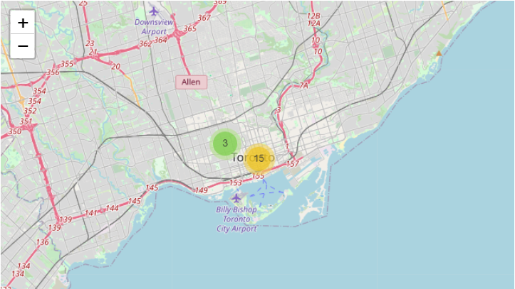

Manhattan map:

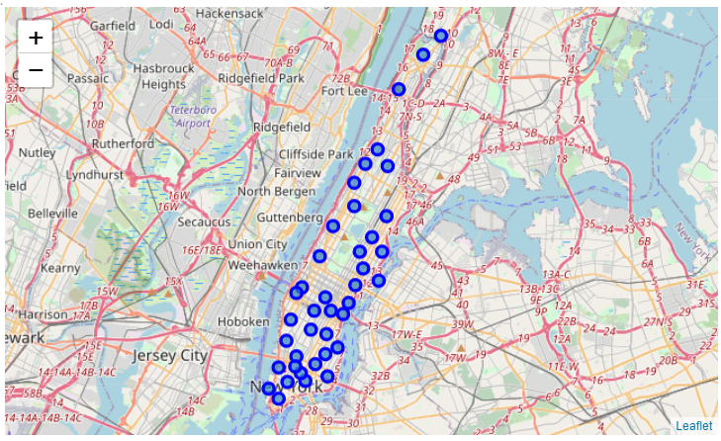

Downtown Toronto venue category:

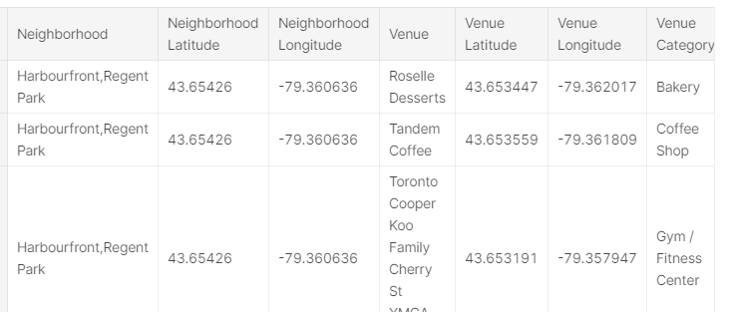

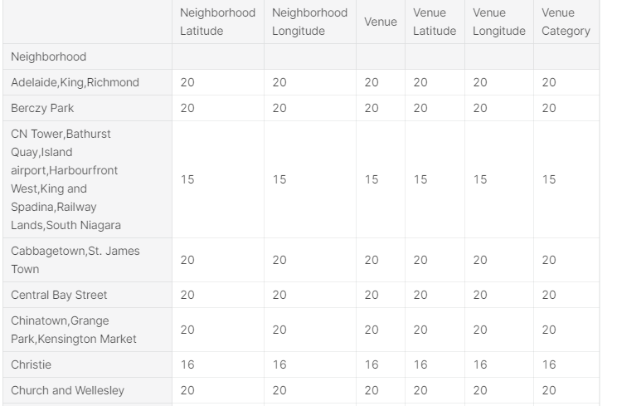

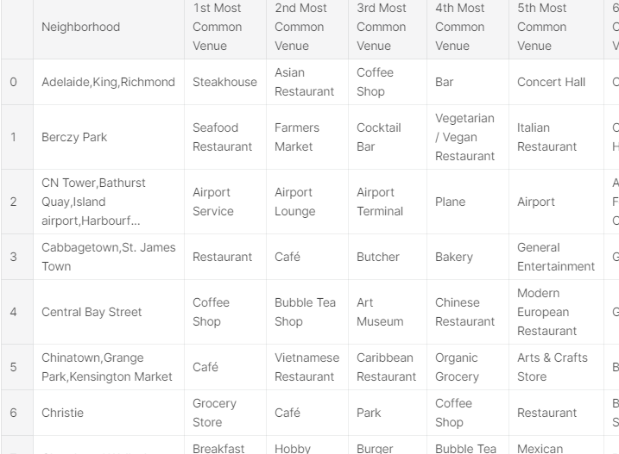

Map clusterwise:

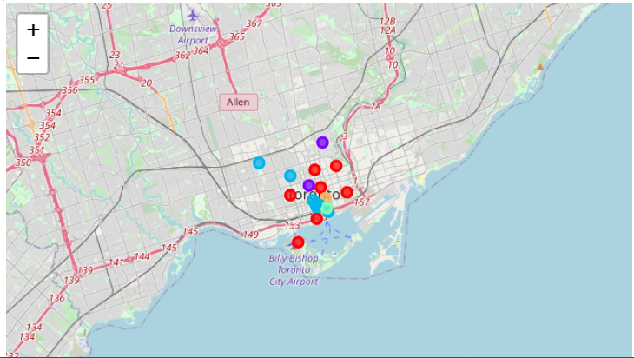

Manhattan cluster :

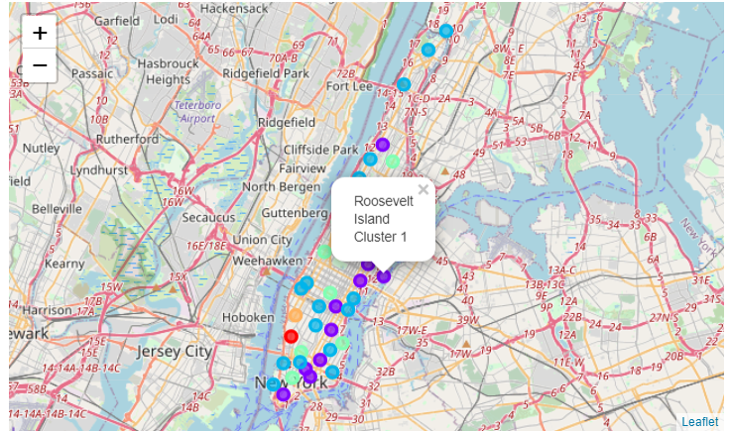

Bar chart population density by borrow.

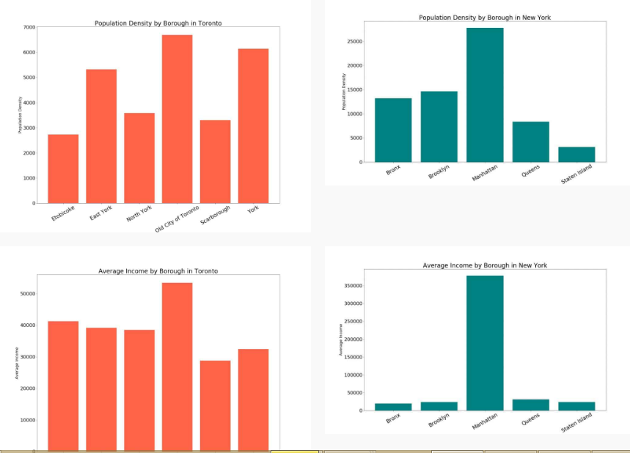

# RESULTS

### After clustering the data of the respective neighborhoods, both cities (Boroughs) have venues which can be explored and attract the Tourists. The neighborhoods are much similar in features like Theaters, opera houses, food places, clubs, museums, parks etc. As far as concern to dissimilarity, it differs in terms of some unique places like historical places and monuments.[¶](https://www.kaggle.com/hark99/clustering-the-battle-of-neighborhoods#After-clustering-the-data-of-the-respective-neighborhoods,-both-cities-(Boroughs)-have-venues-which-can-be-explored-and-attract-the-Tourists.-The-neighborhoods-are-much-similar-in-features-like-Theaters,-opera-houses,-food-places,-clubs,-museums,-parks-etc.-As-far-as-concern-to-dissimilarity,-it-differs-in-terms-of-some-unique-places-like-historical-places-and-monuments.)

# Observations & Recommendations

### When we compare the tourist places, we observe that the historical place is only situated in Downtown Toronto and the Monument or landmark venue is in Manhattan neighborhoods. Similarly, Airport facility, Harbor, Sculpture garden and Boat or ferry services are also available i**n Downtown Toronto while venues like Nightlife, Climbing gym and Museums are present in Manhattan.

### As far as concern to recommendations, we recommend Downtown Toronto Neighborhoods will be considered first to visit. The tourists have an easily travelling access due to Airport facility, which not only saves time but also helps to aves time but also helps to save money. This saved money can be utilized to explore more, the attracting venues.[¶](https://www.kaggle.com/hark99/clustering-the-battle-of-neighborhoods#As-far-as-concern-to-recommendations,-we-recommend-Downtown-Toronto-Neighborhoods-will-be-considered-first-to-visit.-The-tourists-have-an-easily-travelling-access-due-to-Airport-facility,-which-not-only-saves-time-but-also-helps-to-save-money.-This-saved-money-can-be-utilized-to-explore-more,-the-attracting-venues.)

# Conclusion

### The downtown Toronto and Manhattan neighborhoods have more like similar venues. As we know that every place is unique in its own way, so that’s argument is present in both neighborhoods. The dissimilarity exists in terms of some different venues and facilities but not on a larger extent.

Manhattan is better place for restaurant although competition is in both places.